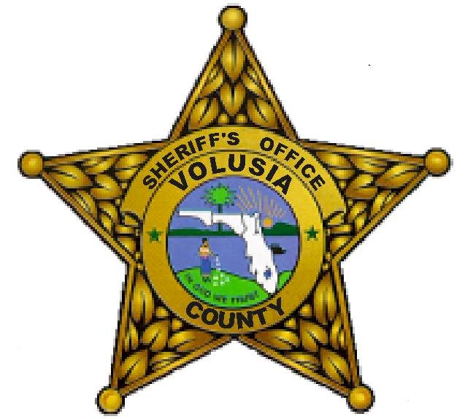Senior Deputy Terrero has been with the Volusia County Sheriff’s office since 2004. In that time he has had numerous assignments to include patrol, street crimes unit, SWAT, investigations, gang task force and is currently assigned to the agencies training unit. Senior Deputy Terrero is a Florida state certified instructor through the Florida Department of Law Enforcement and has been instructing both civilians and law enforcement since 2006.

Civilian Response to an Active Killer Program:

With violence happening daily in schools, businesses, and social settings the more you are prepared now the greater your chances of survival later. This course will discuss what you can do as a civilian should you find yourself in an Active Killer/Active Shooter type of situation. The course will include a powerpoint presentation, video, discussion and question/answer session.

